Ethernet:
Ethernet network is used to create local area network and connect multiple computers or other devices such as printers, scanners, and so on. In a wired network, this is done with the help of fiber optic cables, while in a wireless network, it is done through wireless network technology. An Ethernet network uses various topologies such as star, bus, ring, and more.

- Fast Ethernet: As the term suggests, this is quite a high-speed internet, and can transmit or receive data at about 100 Mbps. This type of network is usually supported by a twisted pair or CAT5 cable. If a laptop, camera, or any other device is connected to a network, they operate at 10/100Base Ethernet and 100Base on the fiber side of the link.
- Gigabit Ethernet: This type of network transfers data at an even higher speed of about 1000 Mbps or 1Gbps. Gigabit speed is an upgrade from Fast Ethernet which is slowly being phased out. In this type of network, all the four pairs in the twisted pair cable contribute to the data transfer speed. This network type finds a large application in video calling systems which use CAT5e or other advanced cables. For extended networks, the distance of up to 500m, 1000Base SX fiber cables may be used for multimode, as well as 1000Base LX for single mode systems. VERSITRON manufactures Gigabit Ethernet Media Converters that can handle 10/100/1000Base speeds on the Ethernet side and 1000Base Gigabit speed on the fiber side by using Fiber SFP modules.
- 10-Gigabit Ethernet: This is an even more advanced and high speed network type with a data transfer rate of 10 Gigabit/second. It is supported by CAT6a or CAT7 twisted pair cables, as well as fiber optic cables. By using a fiber optic cable, this network area can be extended up to around 10,000 meters.
- Switch Ethernet: This type of network requires a switch or hub. Also, instead of a twisted pair cable, a normal network cable is used in this case. Network switches are used for data transfer from one device to the other, without interrupting any other devices in the network.

- 10Base2: This is a thin twisted pair coaxial cable.
- 10Base5: This is thick twisted pair coaxial cables.
- 10Base T: This is a twisted pair cable which offers a speed of around 10 Mbps.
- 100BaseTX: This is a twisted pair cable and offer a speed of 100 Mbps.
- 100Base FX: Fiber optic protocol which offers a speed of 100 Mbps.
- 1000Base SX: Fiber optic protocol which utilizes a wavelength of 850nm for multimode networks.
- 1000Base LX: Fiber optic protocol which utilizes a wavelength of 1310 nm, for multimode networks and up to 1550nm for singlemode networks.

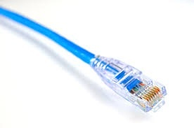

The data transmission range of a typical type is upto 10 Mbps (Megabits for each second). Other types of LANs are Token Ring, 10 Gigabit, Gigabit, Fast, FDDI (Fiber Distributed Data Interface), ATM (Asynchronous Transfer Mode).

- For 10 Mbps bandwidth, the Informal name of Ethernet is 10BASE-T, IEEE name is 802.3, and Cable Type is UTP 100m.
- For 100 Mbps bandwidth, the Fast Ethernet name is 100BASE-T, IEEE name is 802.3u and Cable Type is UTP 100m.
- For 1000 Mbps bandwidth, the Gigabit Ethernet name is 1000BASE-LX, IEEE name is 802.3z and Cable Type is Fiber 5000m
- For 1000 Mbps bandwidth, the Gigabit Ethernet name is 1000BASE-T, IEEE name is 802.3ab and Cable Type is UTP 100m
- For 10 Gbps bandwidth, the 10 Gigabit Ethernet name is 10GBASE-T, IEEE name is 802.3an and Cable Type is UTP 100m

Types of Ethernet Networks
There are several types of Ethernet networks, such as Fast, Gigabit, and Switch. A network is a group of two or more computer systems connected together.

Fast Ethernet
The fast Ethernet is a type of network that can transfer data at a rate of 100 Mbps using a twisted-pair cable or a fiber-optic cable. The older 10 Mbps Ethernet is still used, but such networks do not provide the necessary bandwidth for some network-based video applications.
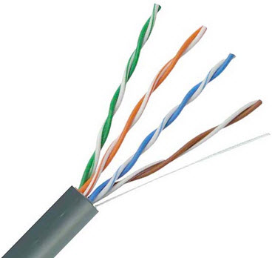Twisted pair cable
Fast type network is based on the proven CSMA/CD Media Access Control (MAC) protocol and uses existing 10BaseT cabling. Data can move from 10 Mbps to 100 Mbps without any protocol translation or changes to the application and networking software.
What is Ethernet Port Speed?
When compared to a 10 Mb port, a 100 Mb port is theoretically 10 times faster than the standard port. Therefore, with a 100 Mb port, more information can stream to and from your server. This will be of great help to you if you really need to explore very high speed, but not if you are under DDOS attack because you will find yourself running out of traffic allocation very fast.
If you are doing standard web hosting, the bigger 100 Mbps pipe will not offer true benefit to you because you may not even use more than 1 Mbps at any given time. If you are hosting games or streaming media, then the bigger pipe of 100 Mbps would indeed be helpful to you.
With a 10 Mbps pipe, you can transfer up to 1.25 Mbps, while a 100 Mbps pipe, would allow you to transfer up to 12.5 Mbps.
However, if you leave your server unattended and running at full steam, a 10 Mbps pipe can consume about 3,240 GB a month and a 100 Mbps pipe can consume up to 32,400 GB a month. It would be really disgusting when you receive your bill.

Gigabit Ethernet
The Gigabit s a type of network capable of transferring data at a rate of 1000 Mbps based on a twisted-pair or fiber optic cable, and it is very popular. The type of twisted-pair cable that supports Gigabit Ethernet is the Cat 5e cable, where all the four pairs of twisted wires of the cable are used to achieve high data transfer rates. The 10 Gigabit Ethernet is the latest-generation, capable of transferring data at a rate of 10 Gbps using twisted-pair or fiber optic cable.
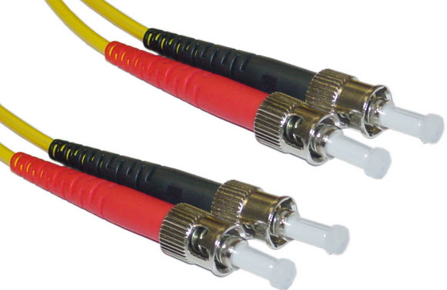Optic fiber cable

Switch Ethernet
Multiple network devices in a LAN require network equipment such as a network switch or hub. When using a network switch, a regular network cable is used instead of a crossover cable. The crossover cable consists of a transmission pair at one end and a receiving pair at the other end.
The main function of a network switch is to forward data from one device to another device on the same network. Thus a network switch performs this task efficiently as the data is transferred from one device to another without affecting other devices on the same network.
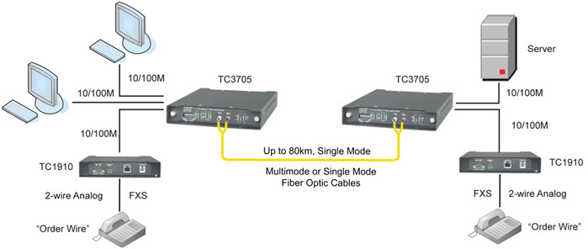Switch Ethernet
The network switch normally supports different data transfer rates. The most common data transfer rates include 10 Mbps – 100 Mbps for fast Ethernet, and 1000 Mbps – 10 Gbps for the latest Ethernet.
This type of network uses a star topology, which is organized around a switch. The switch in a network uses a filtering and switching mechanism similar to the one used by the gateways, in which these techniques have been in use for a long time.

Ethernet Port
An Ethernet port is also called a socket or a jack on a computer network device used to connect the cables. The main function of this port is to connect the hardware of a wired network within MAN (metropolitan area network), an Ethernet LAN, or WAN (wide area network).
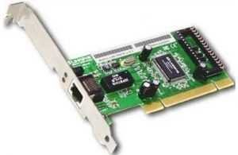Ethernet Port
In computers or laptops, these network connections are available at the backside. A router includes numerous ports to hold several wired devices over a network. This is also applicable to other network devices such as modems and hubs.
A cable that has an RJ45 connector then it supports by an Ethernet port. So, WiFi is an alternative to use a cable through this port so that it eliminates the need for both the port as well as a cable. As compared with a phone jack, this port is wider. So it is not possible to fit this cable into a phone jack because of its shape which makes it simple once plugging in cables. The designing of Ethernet cable can be done with a clip to hold the cable within the Port.
Most of the computers comprise one inbuilt port and the main function of this port is to connect the device toward a wired network. This port can be connected to its inner network adapter known as Ethernet card, which is connected to the motherboard.
Generally, laptops include an Ethernet port, used to connect a network that doesn’t include wireless capabilities. For instance, MacBook Air doesn’t include a port however it supports an Ethernet dongle toward a USB port in the computer.
At present, these ports are available almost in networking devices. These are very powerful tools that can be used to connect several devices mutually through a cable like a router, Xbox, computer, modem, Apple TVs, PlayStation, etc.
In some devices, WiFi technology has replaced the necessity of ports however these are still used in any size of the network. But, a stable, as well as a more reliable network connection, can be obtained by connecting Ethernet ports using a cable.

