Wireless Technologies
Wireless connection to internet is very common these days. Often an external modem is connected to the Internet and other devices connect to it wirelessly. This eliminated the need for last mile or first mile wiring. There are two ways of connecting to the Internet wirelessly – Wi-Fi and WiMAx. Wi-Fi Wi-Fi is the acronym for wireless fidelity. Wi-Fi technology is used to achieve connection to the Internet without a direct cable between device and Internet Service Provider. Wi-Fi enabled device and wireless router are required for setting up a Wi-Fi connection. These are some characteristics of wireless Internet connection –
• Range of 100 yards
• Insecure connection
• Throughput of 10-12 Mbps
If a PC or laptop does not have Wi-Fi capacity, it can be added using a Wi-Fi card



The physical area of the network which provides Internet access through Wi-Fi is called Wi-Fi hotspot. Hotspots can be set up at home, office or any public space like airport, railway stations, etc. Hotspots themselves are connected to the network through wires.
WiMax (802.16 )
To overcome the drawback of Wi-Fi connections, WiMax (Worldwide Interoperability for Microwave Access) was developed. WiMax is a collection of wireless communication standards based on IEEE 802.16. WiMax provides multiple physical layer and media access control (MAC) options. WiMax Forum, established in 2001, is the principal body responsible to ensure conformity and interoperability among various commercial vendors. These are some of the characteristics of WiMax − • Broadband wireless access • Range of 6 miles • Multilevel encryption available • Throughput of 72 Mbps The main components of a WiMax unit are − • WiMax Base Station − It is a tower similar to mobile towers and connected to Internet through high speed wired connection. • WiMax Subscriber Unit (SU) − It is a WiMax version of wireless modem. The only difference is that modem is connected to the Internet through cable connection whereas WiMax SU receives Internet connection wirelessly through microwaves.
IEEE 802.20 or Mobile Broadband Wireless Access (MBWA)
It was a specification by the standard association of the Institute of Electrical and Electronics Engineers (IEEE) for mobile broadband networks. The main standard was published in 2008. MBWA is no longer being actively developed.
This wireless broadband technology is also known and promoted as iBurst (or HC-SDMA, High Capacity Spatial Division Multiple Access). It was originally developed by Array COMM and optimizes the use of its bandwidth with the help of smart antennas. Kyocera is the manufacturer of iBurst devices.
The HC-SDMA interface provides wide-area broadband wireless data-connectivity for fixed, portable and mobile computing devices and appliances. The protocol is designed to be implemented with smart antenna array techniques (called MIMO for multiple-input multiple-output) to substantially improve the radio frequency (RF) coverage, capacity and performance for the system. In January 2006, the IEEE 802.20 Mobile Broadband Wireless Access Working Group adopted a technology proposal that included the use of the HC-SDMA standard for the 625kHz Multi-Carrier time-division duplex (TDD) mode of the standard. One Canadian vendor operates at 1.8 GHz.

Mobile Ad hoc Network (MANET)

MANET stands for Mobile Adhoc Network also called a wireless Adhoc network or Adhoc wireless network that usually has a routable networking environment on top of a Link Layer ad hoc network.. They consist of a set of mobile nodes connected wirelessly in a self-configured, self-healing network without having a fixed infrastructure. MANET nodes are free to move randomly as the network topology changes frequently. Each node behaves as a router as they forward traffic to other specified nodes in the network.
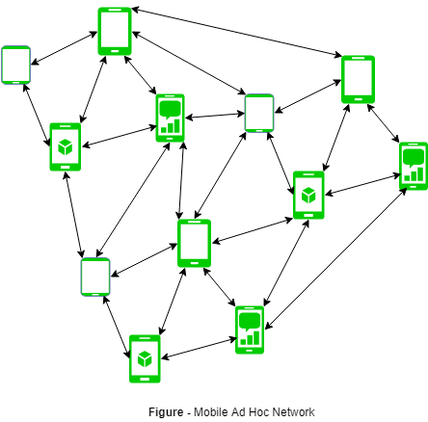
MANET may operate a standalone fashion or they can be part of larger internet. They form a highly dynamic autonomous topology with the presence of one or multiple different transceivers between nodes. The main challenge for the MANET is to equip each device to continuously maintain the information required to properly route traffic. MANETs consist of a peer-to-peer, self-forming, self-healing network MANET’s circa 2000-2015 typically communicate at radio frequencies (30MHz-5GHz). This can be used in road safety, ranging from sensors for the environment, home, health, disaster rescue operations, air/land/navy defense, weapons, robots, etc.
Characteristics of MANET –
- Dynamic Topologies:
Network topology which is typically multihop may change randomly and rapidly with time, it can form unidirectional or bi-directional links.
- Bandwidth constrained, variable capacity links:
Wireless links usually have lower reliability, efficiency, stability, and capacity as compared to a wired network
- Autonomous Behavior:
Each node can act as a host and router, which shows its autonomous behavior.
- Energy Constrained Operation:
As some or all the nodes rely on batteries or other exhaustible means for their energy. Mobile nodes are characterized by less memory, power, and lightweight features.
- Limited Security:
Wireless networks are more prone to security threats. A centralized firewall is absent due to the distributed nature of the operation for security, routing, and host configuration.
- Less Human Intervention:
They require minimum human intervention to configure the network, therefore they are dynamically autonomous in nature.
Pros and Cons of MANET –
Pros:
- Separation from central network administration.
- Each node can play both the roles ie. of router and host showing autonomous nature.
- Self-configuring and self-healing nodes do not require human intervention.
- Highly scalable and suits the expansion of more network hub.
Cons:
- Resources are limited due to various constraints like noise, interference conditions, etc.
- Lack of authorization facilities.
- More prone to attacks due to limited physical security.
- High latency i.e. There is a huge delay in the transfer of data between two sleeping nodes.

Wireless Sensor Network (WSN):

Wireless Sensor Network (WSN) is an infrastructure-less wireless network that is deployed in a large number of wireless sensors in an ad-hoc manner that is used to monitor the system, physical or environmental conditions.
Sensor nodes are used in WSN with the onboard processor that manages and monitors the environment in a particular area. They are connected to the Base Station which acts as a processing unit in the WSN System.Base Station in a WSN System is connected through the Internet to share data.

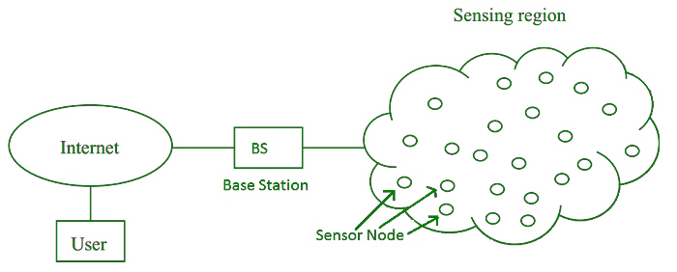
WSN can be used for processing, analysis, storage, and mining of the data.
Applications of WSN:
- Internet of Things (IOT)
- Surveillance and Monitoring for security, threat detection
- Environmental temperature, humidity, and air pressure
- Noise Level of the surrounding
- Medical applications like patient monitoring
- Agriculture
- Landslide Detection
Challenges of WSN:
- Quality of Service
- Security Issue
- Energy Efficiency
- Network Throughput
- Performance
- Ability to cope with node failure
- Cross layer optimisation
- Scalability to large scale of deployment
Components of WSN:
- Sensors:
Sensors in WSN are used to capture the environmental variables and which is used for data acquisition. Sensor signals are converted into electrical signals.
- Radio Nodes:
It is used to receive the data produced by the Sensors and sends it to the WLAN access point. It consists of a microcontroller, transceiver, external memory, and power source.
- WLAN Access Point:
It receives the data which is sent by the Radio nodes wirelessly, generally through the internet.
- Evaluation Software:
The data received by the WLAN Access Point is processed by a software called as Evaluation Software for presenting the report to the users for further processing of the data which can be used for processing, analysis, storage, and mining of the data.

