Switching
- When a user accesses the internet or another computer network outside their immediate location, messages are sent through the network of transmission media. This technique of transferring the information from one computer network to another network is known as switching.
- Switching in a computer network is achieved by using switches. A switch is a small hardware device which is used to join multiple computers together with one local area network (LAN).
- Network switches operate at layer 2 (Data link layer) in the OSI model.
- Switching is transparent to the user and does not require any configuration in the home network.
- Switches are used to forward the packets based on MAC addresses.
- A Switch is used to transfer the data only to the device that has been addressed. It verifies the destination address to route the packet appropriately.
- It is operated in full duplex mode.
- Packet collision is minimum as it directly communicates between source and destination.
- It does not broadcast the message as it works with limited bandwidth.

Why is Switching Concept required?
Switching concept is developed because of the following reasons:
- Bandwidth: It is defined as the maximum transfer rate of a cable. It is a very critical and expensive resource. Therefore, switching techniques are used for the effective utilization of the bandwidth of a network.
- Collision: Collision is the effect that occurs when more than one device transmits the message over the same physical media, and they collide with each other. To overcome this problem, switching technology is implemented so that packets do not collide with each other.

Advantages of Switching:
- Switch increases the bandwidth of the network.
- It reduces the workload on individual PCs as it sends the information to only that device which has been addressed.
- It increases the overall performance of the network by reducing the traffic on the network.
- There will be less frame collision as switch creates the collision domain for each connection.

Disadvantages of Switching:
- A Switch is more expensive than network bridges.
- A Switch cannot determine the network connectivity issues easily.
- Proper designing and configuration of the switch are required to handle multicast packets.

Switching Modes
- The layer 2 switches are used for transmitting the data on the data link layer, and it also performs error checking on transmitted and received frames.
- The layer 2 switches forward the packets with the help of MAC address.
- Different modes are used for forwarding the packets known as Switching modes.
- In switching mode, Different parts of a frame are recognized. The frame consists of several parts such as preamble, destination MAC address, source MAC address, user's data, FCS.
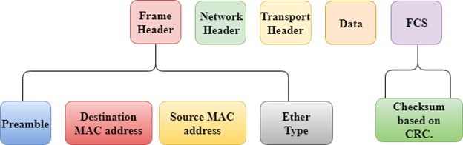
There are three types of switching modes:
- Store-and-forward
- Cut-through
- Fragment-free
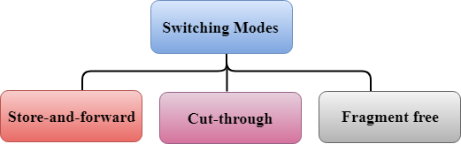

Store-and-forward
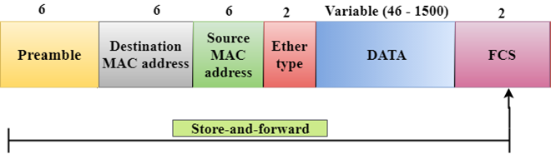
- Store-and-forward is a technique in which the intermediate nodes store the received frame and then check for errors before forwarding the packets to the next node.
- The layer 2 switch waits until the entire frame has received. On receiving the entire frame, switch store the frame into the switch buffer memory. This process is known as storing the frame.
- When the frame is stored, then the frame is checked for the errors. If any error found, the message is discarded otherwise the message is forwarded to the next node. This process is known as forwarding the frame.
- CRC (Cyclic Redundancy Check) technique is implemented that uses a number of bits to check for the errors on the received frame.
- The store-and-forward technique ensures a high level of security as the destination network will not be affected by the corrupted frames.
- Store-and-forward switches are highly reliable as it does not forward the collided frames.

Cut-through Switching
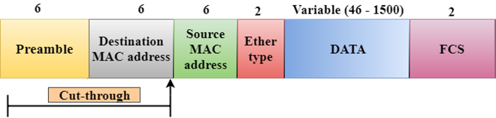

- Cut-through switching is a technique in which the switch forwards the packets after the destination address has been identified without waiting for the entire frame to be received.
- Once the frame is received, it checks the first six bytes of the frame following the preamble, the switch checks the destination in the switching table to determine the outgoing interface port, and forwards the frame to the destination.
- It has low latency rate as the switch does not wait for the entire frame to be received before sending the packets to the destination.
- It has no error checking technique. Therefore, the errors can be sent with or without errors to the receiver.
- A Cut-through switching technique has low wait time as it forwards the packets as soon as it identifies the destination MAC address.
- In this technique, collision is not detected, if frames have collided will also be forwarded.

Fragment-free Switching
- 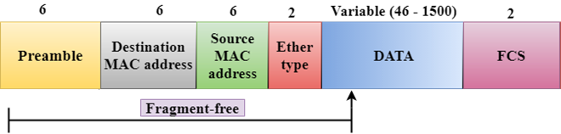
A Fragment-free switching is an advanced technique of the Cut-through Switching.
- A Fragment-free switching is a technique that reads atleast 64 bytes of a frame before forwarding to the next node to provide the error-free transmission.
- It combines the speed of Cut-through Switching with the error checking functionality.
- This technique checks the 64 bytes of the ethernet frame where addressing information is available.
- A collision is detected within 64 bytes of the frame, the frames which are collided will not be forwarded further.

Differences b/w Store-and-forward and Cut-through Switching.
Store-and-forward Switching | Cut-through Switching
Store-and-forward Switching is a technique that waits until the entire frame is received. | Cut-through Switching is a technique that checks the first 6 bytes following the preamble to identify the destination address.
It performs error checking functionality. If any error is found in the frame, the frame will be discarded otherwise forwarded to the next node. | It does not perform any error checking. The frame with or without errors will be forwarded.
It has high latency rate as it waits for the entire frame to be received before forwarding to the next node. | It has low latency rate as it checks only six bytes of the frame to determine the destination address.
It is highly reliable as it forwards only error-free packets. | It is less reliable as compared to Store-and-forward technique as it forwards error prone packets as well.
It has a high wait time as it waits for the entire frame to be received before taking any forwarding decisions. | It has low wait time as cut-through switches do not store the whole frame or packets.

Switching techniques
In large networks, there can be multiple paths from sender to receiver. The switching technique will decide the best route for data transmission.
Switching technique is used to connect the systems for making one-to-one communication.
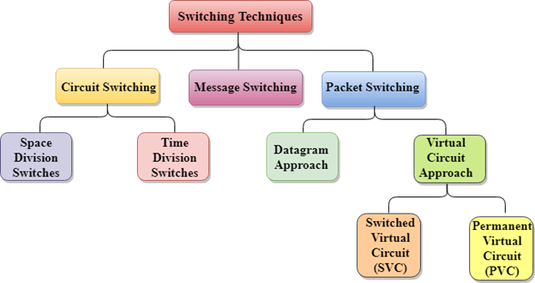

Circuit Switching
- Circuit switching is a switching technique that establishes a dedicated path between sender and receiver.
- In the Circuit Switching Technique, once the connection is established then the dedicated path will remain to exist until the connection is terminated.
- Circuit switching in a network operates in a similar way as the telephone works.
- A complete end-to-end path must exist before the communication takes place.
- In case of circuit switching technique, when any user wants to send the data, voice, video, a request signal is sent to the receiver then the receiver sends back the acknowledgment to ensure the availability of the dedicated path. After receiving the acknowledgment, dedicated path transfers the data.
- Circuit switching is used in public telephone network. It is used for voice transmission.
- Fixed data can be transferred at a time in circuit switching technology.

Communication through circuit switching has 3 phases:
- Circuit establishment
- Data transfer
- Circuit Disconnect
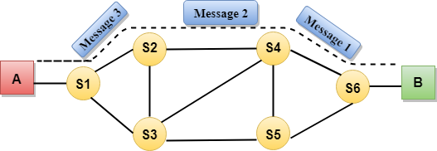
Circuit Switching can use either of the two technologies:

Space Division Switches:
- Space Division Switching is a circuit switching technology in which a single transmission path is accomplished in a switch by using a physically separate set of crosspoints.
- Space Division Switching can be achieved by using crossbar switch. A crossbar switch is a metallic crosspoint or semiconductor gate that can be enabled or disabled by a control unit.
- The Crossbar switch is made by using the semiconductor. For example, Xilinx crossbar switch using FPGAs.
- Space Division Switching has high speed, high capacity, and nonblocking switches.
Space Division Switches can be categorized in two ways:
- Crossbar Switch
- Multistage Switch

Crossbar Switch
The Crossbar switch is a switch that has n input lines and n output lines. The crossbar switch has n² intersection points known as crosspoints.

Disadvantage of Crossbar switch:
The number of crosspoints increases as the number of stations is increased. Therefore, it becomes very expensive for a large switch. The solution to this is to use a multistage switch.

Multistage Switch
- Multistage Switch is made by splitting the crossbar switch into the smaller units and then interconnecting them.
- It reduces the number of crosspoints.
- If one path fails, then there will be an availability of another path.
Advantages Of Circuit Switching:
- In the case of Circuit Switching technique, the communication channel is dedicated.
- It has fixed bandwidth.
Disadvantages Of Circuit Switching:
- Once the dedicated path is established, the only delay occurs in the speed of data transmission.
- It takes a long time to establish a connection approx 10 seconds during which no data can be transmitted.
- It is more expensive than other switching techniques as a dedicated path is required for each connection.
- It is inefficient to use because once the path is established and no data is transferred, then the capacity of the path is wasted.
- In this case, the connection is dedicated therefore no other data can be transferred even if the channel is free.

Message Switching
- Message Switching is a switching technique in which a message is transferred as a complete unit and routed through intermediate nodes at which it is stored and forwarded.
- In Message Switching technique, there is no establishment of a dedicated path between the sender and receiver.
- The destination address is appended to the message. Message Switching provides a dynamic routing as the message is routed through the intermediate nodes based on the information available in the message.
- Message switches are programmed in such a way so that they can provide the most efficient routes.
- Each and every node stores the entire message and then forward it to the next node. This type of network is known as store and forward network.
- Message switching treats each message as an independent entity.
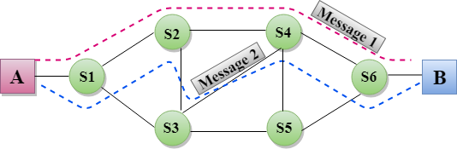

Advantages Of Message Switching

Data channels are shared among the communicating devices that improve the efficiency of using available bandwidth.
Traffic congestion can be reduced because the message is temporarily stored in the nodes.
Message priority can be used to manage the network.
The size of the message which is sent over the network can be varied. Therefore, it supports the data of unlimited size.
Disadvantages Of Message Switching

The message switches must be equipped with sufficient storage to enable them to store the messages until the message is forwarded.
The Long delay can occur due to the storing and forwarding facility provided by the message switching technique.
Packet Switching
The packet switching is a switching technique in which the message is sent in one go, but it is divided into smaller pieces, and they are sent individually.
The message splits into smaller pieces known as packets and packets are given a unique number to identify their order at the receiving end.
Every packet contains some information in its headers such as source address, destination address and sequence number.
Packets will travel across the network, taking the shortest path as possible.
All the packets are reassembled at the receiving end in correct order.
If any packet is missing or corrupted, then the message will be sent to resend the message.
If the correct order of the packets is reached, then the acknowledgment message will be sent.

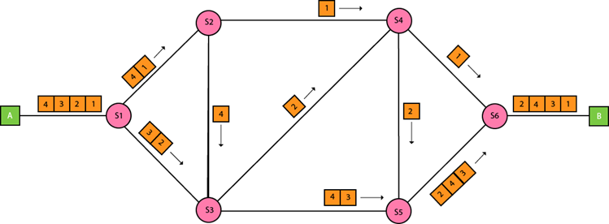

Approaches Of Packet Switching:
There are two approaches to Packet Switching:

Datagram Packet switching:
- It is a packet switching technology in which packet is known as a datagram, is considered as an independent entity. Each packet contains the information about the destination and switch uses this information to forward the packet to the correct destination.
- The packets are reassembled at the receiving end in correct order.
- In Datagram Packet Switching technique, the path is not fixed.
- Intermediate nodes take the routing decisions to forward the packets.
- Datagram Packet Switching is also known as connectionless switching.

Virtual Circuit Switching
- Virtual Circuit Switching is also known as connection-oriented switching.
- In the case of Virtual circuit switching, a preplanned route is established before the messages are sent.
- Call request and call accept packets are used to establish the connection between sender and receiver.
- In this case, the path is fixed for the duration of a logical connection.
Let's understand the concept of virtual circuit switching through a diagram:
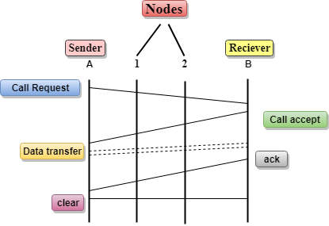
- In the above diagram, A and B are the sender and receiver respectively. 1 and 2 are the nodes.
- Call request and call accept packets are used to establish a connection between the sender and receiver.
- When a route is established, data will be transferred.
- After transmission of data, an acknowledgment signal is sent by the receiver that the message has been received.
- If the user wants to terminate the connection, a clear signal is sent for the termination.

Differences b/w Datagram approach and Virtual Circuit approach
Datagram approach | Virtual Circuit approach
Node takes routing decisions to forward the packets. | Node does not take any routing decision.
Congestion cannot occur as all the packets travel in different directions. | Congestion can occur when the node is busy, and it does not allow other packets to pass through.
It is more flexible as all the packets are treated as an independent entity. | It is not very flexible.
Advantages Of Packet Switching:
- Cost-effective: In packet switching technique, switching devices do not require massive secondary storage to store the packets, so cost is minimized to some extent. Therefore, we can say that the packet switching technique is a cost-effective technique.
- Reliable: If any node is busy, then the packets can be rerouted. This ensures that the Packet Switching technique provides reliable communication.
- Efficient: Packet Switching is an efficient technique. It does not require any established path prior to the transmission, and many users can use the same communication channel simultaneously, hence makes use of available bandwidth very efficiently.
Disadvantages Of Packet Switching:
- Packet Switching technique cannot be implemented in those applications that require low delay and high-quality services.
- The protocols used in a packet switching technique are very complex and requires high implementation cost.
- If the network is overloaded or corrupted, then it requires retransmission of lost packets. It can also lead to the loss of critical information if errors are nor recovered.

