Unit No.2 : Data Transmission and Physical Layer
Signal:
A signal is an electromagnetic or electrical current that is used for carrying data from one system or network to another. It refers to any time-varying voltage that is an electromagnetic wave which carries information.
There are two main types of signals: Analog signal and Digital signal.
Analog Signal :
Analog signal is a continuous signal in which one time-varying quantity represents another time-based variable. These kind of signals works with physical values and natural phenomena such as earthquake, frequency, volcano, speed of wind, weight, lighting, etc.
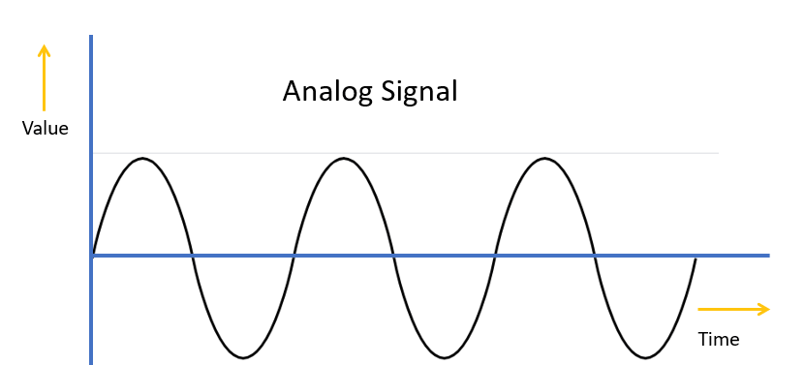
Analog Signal
Digital Signal
A digital signal is a signal that is used to represent data as a sequence of separate values at any point in time. It can only take on one of a fixed number of values. This type of signal represents a real number within a constant range of values.
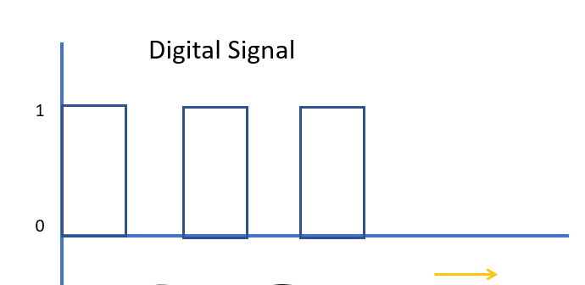
Time

Difference Between Analog Signals and Digital Signals
Analog | Digital
An analog signal is a continuous signal that represents physical measurements. | Digital signals are time separated signals which are generated using digital modulation.
It is denoted by sine waves | It is denoted by square waves
It uses a continuous range of values that help you to represent information. | Digital signal uses discrete 0 and 1 to represent information.
Temperature sensors, FM radio signals, Photocells, Light sensor, Resistive touch screen are examples of Analog signals. | Computers, CDs, DVDs are some examples of Digital signal.
The analog signal bandwidth is low | The digital signal bandwidth is high.
Analog signals are deteriorated by noise throughout transmission as well as write/read cycle. | Relatively a noise-immune system without deterioration during the transmission process and write/read cycle.
Analog hardware never offers flexible implementation. | Digital hardware offers flexibility in implementation.
It is suited for audio and video transmission. | It is suited for Computing and digital electronics.
Processing can be done in real-time and consumes lesser bandwidth compared to a digital signal. | It never gives a guarantee that digital signal processing can be performed in real time.
Analog instruments usually have s scale which is cramped at lower end and gives considerable observational errors. | Digital instruments never cause any kind of observational errors.
Analog signal doesn’t offer any fixed range. | Digital signal has a finite number, i.e., 0 and 1.

Data Rate :
Data Rate is defined as the amount of data transmitted during a specified time period over a network. It is the speed at which data is transferred from one device to another or between a peripheral device and the computer. It is generally measured in Mega bits per second(Mbps) or Mega bytes per second(MBps). For example, if bandwidth is 100 Mbps but data rate is 50 Mbps, it means maximum 100 Mb data can be transferred but channel is transmitting only 50 Mb data per second.

Transmission Impairment:

In communication system, analog signals travel through transmission media, which tends to deteriorate the quality of analog signal, which means that the signal at the beginning of the medium is not the same as the signal at the end of the medium. The imperfection causes signal impairment. Below are the causes of the impairment.
Causes of impairment –

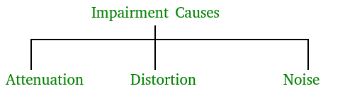

- Attenuation – It means loss of energy. The strength of signal decreases with increasing distance which causes loss of energy in overcoming resistance of medium. This is also known as attenuated signal. Amplifiers are used to amplify the attenuated signal which gives the original signal back and compensate for this loss.

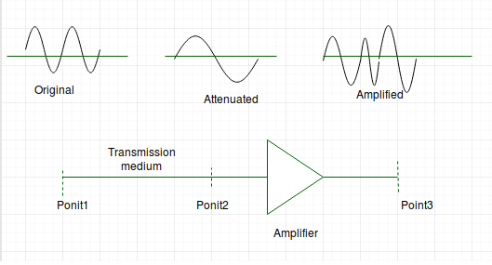
Attenuation is measured in decibels(dB). It measures the relative strengths of two signals or one signal at two different point.
Attenuation(dB) = 10log10(P2/P1)
P1 is the power at sending end and P2 is the power at receiving end.
Some where the decibel is also define in terms of voltage instead of power.In this case because power is proportional to the square of the voltage the formula is
Attenuation(dB) = 20log10(V2/V1)
V1 is the voltage at sending end and V2 is the voltage at receiving end.
- Distortion – It means changes in the form or shape of the signal. This is generally seen in composite signals made up with different frequencies. Each frequency component has its own propagation speed travelling through a medium. And thats why it delay in arriving at the final destination Every component arrive at different time which leads to distortion. Therefore, they have different phases at receiver end from what they had at senders end.
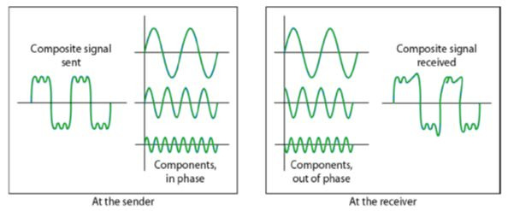

- Noise – The random or unwanted signal that mixes up with the original signal is called noise. There are several types of noise such as induced noise, crosstalk noise, thermal noise and impulse noise which may corrupt the signal.
Induced noise comes from sources such as motors and appliances. These devices act as sending antenna and transmission medium act as receiving antenna. Thermal noise is movement of electrons in wire which creates an extra signal. Crosstalk noise is when one wire affects the other wire. Impulse noise is a signal with high energy that comes from lightning or power lines
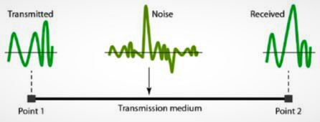
- To find the theoretical bit rate limit, we need to know the ration .The signal-to-noise ratio is defined as
SNR = AVG SIGNAL POWER / AVG NOISE POWER

Signal Measurement :

Bandwidth :
Bandwidth is defined as the potential of the data that is to be transferred in a specific period of time. It is the data carrying capacity of the network or transmission medium. In simple words, it is the maximum amount of data that can be transferred per second on a link. It is generally measured in bits per second(bps), Mega bits per second(Mbps) or Giga bits per second(Gbps). For example, if bandwidth is 100 Mbps, it means maximum 100 Mb data can be transferred per second on that channel.
“Bandwidth” means “Capacity” and “Speed” means “Transfer rate”.

THROUGHPUT :
Throughput is the number of messages successfully transmitted per unit time. It is controlled by available bandwidth, the available signal-to-noise ratio and hardware limitations. The maximum throughput of a network may be consequently higher than the actual throughput achieved in everyday consumption.
Throughput is measured by tabulating the amount of data transferred between multiple locations during a specific period of time, usually resulting in the unit of bits per second(bps), which has evolved to bytes per second(Bps), kilobytes per second(KBps), megabytes per second(MBps) and gigabytes per second(GBps).

Propagation Time:

It is the time required for a bit to travel from the source to the destination. Propagation time can be calculated as the ratio between the link length (distance) and the propagation speed over the communicating medium. For example, for an electric signal, propagation time is the time taken for the signal to travel through a wire.

Propagation time = Distance / Propagation speed

Example:
Input: What will be the propagation time when the distance between two points is
12, 000 km? Assuming the propagation speed to be 2.4 * 10^8 m/s in cable.

Output: We can calculate the propagation time as-
Propagation time = (12000 * 10000) / (2.4 * 10^8) = 50 ms

Propagation speed:
It is the rate at which a signal passes along a wire or cable (or is propagated across it) in a network. Propagation speed is also referred to as velocity factor or velocity of propagation; velocity is perhaps the better term because it refers to the specific definition of rate

Wavelength (λ) - The wavelength of light is defined as the distance between the crests or troughs of a wave motion.
Frequency (f) - Frequency is the number of occurrences of a repeating event per unit time. In the case of light, frequency refers to the number of times a wavelength is repeated per second.

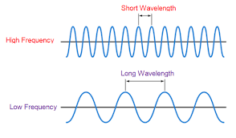

Spectrum:
Spectrum refers to the entire range of frequencies right from the starting frequency (the lowest frequency) to the ending frequency (the highest frequency). Spectrum basically refers to the entire group of frequencies.

