X.25:
X.25 is generally a protocol that was developed by International Telecommunications Union (ITU). It usually allows various logical channels to make use of same physical line. It basically defines a series of documents particularly issued by ITU. These documents are also known as X.25 Recommendations. X.25 also supports various conversations by multiplexing packets and also with the help of virtual communication channels. X.25 basically encompasses or suits to the lower three layers of the Open System Interconnection (OSI) reference model for networking.
These three protocol layers are :
- Physical Layer
- Frame Layer
- Packet Layer
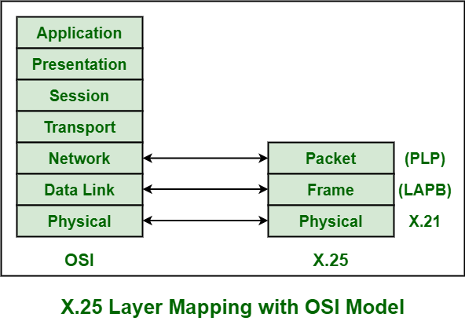
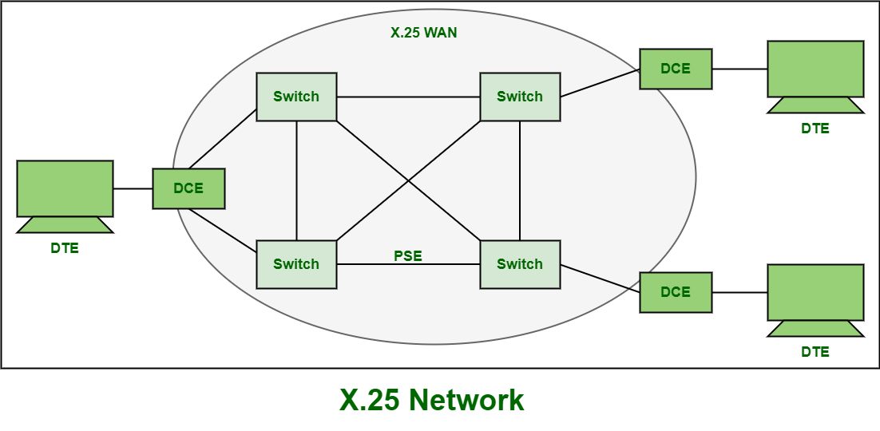
Frame Relay :
Frame Relay is a packet-switching network protocol that is designed to work at the data link layer of the network. It is used to connect Local Area Networks (LANs) and transmit data across Wide Area Networks (WANs). It is a better alternative to a point-to-point network for connecting multiple nodes that require separate dedicated links to be established between each pair of nodes. It allows transmission of different size packets and dynamic bandwidth allocation. Also, it provides a congestion control mechanism to reduce the network overheads due to congestion. It does not have an error control and flow management mechanism.
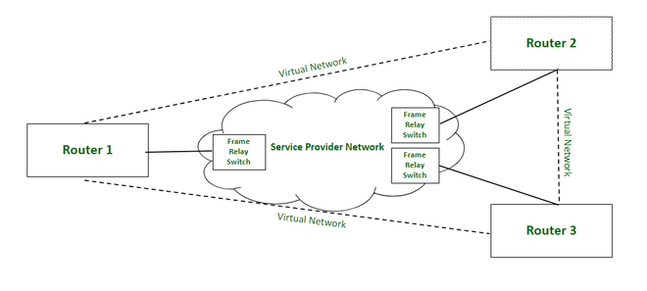

ISDN:
ISDN stands for Integrated Services Digital Network. It is used to bridge the Central Office's local loop and the premise connection (home). ISDN uses the existing wiring so that no new cabling is required. It is a digital service that restores the analog plain old telephone set.
An Integrated Digital Network (ISDN) is a network in which digital switching connections are used to transmit digital signals. Integrated Services refers to ISDNs ability to deliver two simultaneous connections, in any merging of data, voice, video and fax, over an individual line. Multiple devices can be connected to the line and sent as needed.
An ISDN is a network, in general evolving from telephony ISDN, which provides end-toend digital connectivity to provide a broad range of services such as voice and non-voice services, to which customers have to create by a limited set of standard multipurpose user network interfaces.

Advantages
- ISDN is a mature technology, and it has been around since the late 1980s. It has been tried, tested and works.
- A worldwide set of standards governs it.
- It offers symmetrical transfer rates− the transmit rate is the same as the receiving rate.
- It has consistent transfer rates. If you have a 64 Kbps bearer channel, then it is the speed that you transfer at.
- It is a competitive price compared to other technologies.

Disadvantages
- An external power supply is required. The telecommunication doesn't supply power for ISDN lines. If the power fails, the mobile phones won't work.
- Unique digital phones are necessary or a terminal adapter to talk to the existing plain old telephone set devices.
- It is costly to upgrade a central office switch ($500,000+) to ISDN.
- If the ISDN fails-the phone fails.

ATM and ATM Networks
ATM stands for Asynchronous Transfer Mode. It is a switching technique that uses time division multiplexing (TDM) for data communications.
ATM networks are connection oriented networks for cell relay that supports voice, video and data communications. It encodes data into small fixed - size cells so that they are suitable for TDM and transmits them over a physical medium.
The size of an ATM cell is 53 bytes: 5 byte header and 48 byte payload. There are two different cell formats - user-network interface (UNI) and network-network interface (NNI). The below image represents the Functional Reference Model of the Asynchronous Transfer Mode.
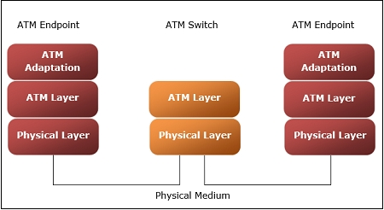

Benefits of ATM Networks are
- It provides the dynamic bandwidth that is particularly suited for bursty traffic.
- Since all data are encoded into identical cells, data transmission is simple, uniform and predictable.
- Uniform packet size ensures that mixed traffic is handled efficiently.
- Small sized header reduces packet overload, thus ensuring effective bandwidth usage.
- ATM networks are scalable both in size and speed.

ATM reference model comprises of three layers
- Physical Layer − This layer corresponds to physical layer of OSI model. At this layer, the cells are converted into bit streams and transmitted over the physical medium. This layer has two sub layers: PMD sub layer (Physical Medium Dependent) and TC (Transmission Convergence) sub layer.
- ATM Layer −This layer is comparable to data link layer of OSI model. It accepts the 48 byte segments from the upper layer, adds a 5 byte header to each segment and converts into 53 byte cells. This layer is responsible for routing of each cell, traffic management, multiplexing and switching.
- ATM Adaptation Layer (AAL) −This layer corresponds to network layer of OSI model. It provides facilities to the existing packet switched networks to connect to ATM network and use its services. It accepts the data and converts them into fixed sized segments. The transmissions can be of fixed or variable data rate. This layer has two sub layers − Convergence sub layer and Segmentation and Reassembly sub layer.
- ATM endpoints − It contains ATM network interface adaptor. Examples of endpoints are workstations, routers, CODECs, LAN switches, etc.
- ATM switch −It transmits cells through the ATM networks. It accepts the incoming cells from ATM endpoints (UNI) or another switch (NNI), updates cell header and retransmits cell towards destination.

