Hierarchical routing
In hierarchical routing, the routers are divided into regions. Each router has complete details about how to route packets to destinations within its own region. But it does not have any idea about the internal structure of other regions.
As we know, in both LS and DV algorithms, every router needs to save some information about other routers. When network size is growing, the number of routers in the network will increase. Therefore, the size of routing table increases, then routers cannot handle network traffic as efficiently. To overcome this problem we are using hierarchical routing.
In hierarchical routing, routers are classified in groups called regions. Each router has information about the routers in its own region and it has no information about routers in other regions. So, routers save one record in their table for every other region.
For huge networks, a two-level hierarchy may be insufficient hence, it may be necessary to group the regions into clusters, the clusters into zones, the zones into groups and so on.

Example
Consider an example of two-level hierarchy with five regions as shown in figure −

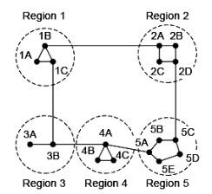

Let see the full routing table for router 1A which has 17 entries, as shown below −

Full Table for 1A
Dest. | Line | Hops
1A | - | -
1B | 1B | 1
1C | 1C | 1
2A | 1B | 2
2B | 1B | 3
2C | 1B | 3
2D | 1B | 4
3A | 1C | 3
3B | 1C | 2
4A | 1C | 3
4B | 1C | 4
4C | 1C | 4
5A | 1C | 4
5B | 1C | 5
5C | 1B | 5
5D | 1C | 6
5E | 1C | 5

When routing is done hierarchically then there will be only 7 entries as shown below

Hierarchical Table for 1A
Dest. | Line | Hops
1A | - | -
1B | 1B | 1
1C | 1C | 1
2 | 1B | 2
3 | 1C | 2
4 | 1C | 3
5 | 1C | 4
Unfortunately, this reduction in table space comes with the increased path length.

Broadcast and Multicast Routing :
Casting in computer networks means transmitting data (stream of packets) over a network. Following are the different types of casting used in networking –

- Unicast transmission
- Broadcast transmission
- Multicast transmission

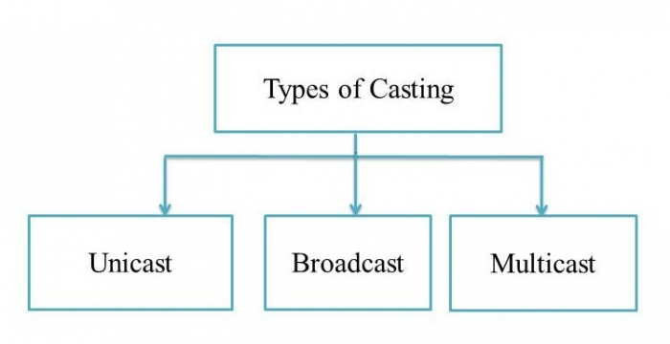

Unicast Transmission (One-to-One)
In Unicast transmission, the data is transferred from a single sender (or a single source host) to a single receiver (or a single destination host).

Example
In the following figure, Host A sends the IP address 11.1.2.2 data to the Host B IP address 20.12.4.3.
- Source Address = IP address of host A is 11.1.2.2
- Destination Address = IP address of host B is 20.12.4.3

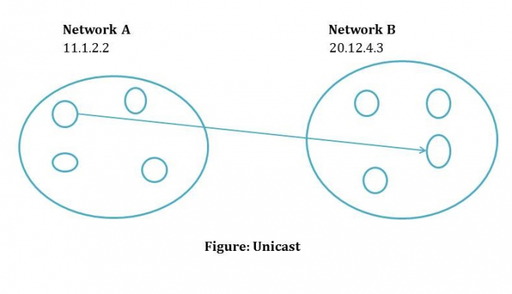

Unicast routing
Most of the traffic on the internet and intranets known as unicast data or unicast traffic is sent with specified destination. Routing unicast data over the internet is called unicast routing. It is the simplest form of routing because the destination is already known. Hence the router just has to look up the routing table and forward the packet to next hop.

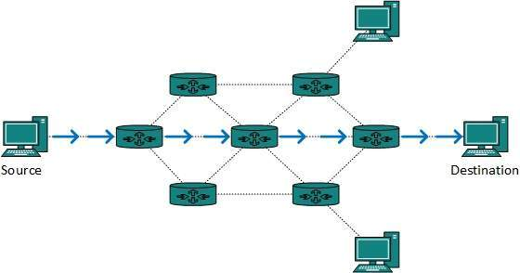

Broadcast Transmission (One-to-All)
In Broadcast transmission, the data is transmitted from one or more senders to all the receivers within the same network or in other networks. This type of transmission is useful in network management packets such as ARP (Address Resolution Protocol) and RIP (Routing Information Protocol) where all the devices must see the data.
There are two types of broadcast transmission −
- Directed Broadcast, and
- Limited Broadcast

Directed Broadcast
Directed Broadcast transmits data from one source host to all the other hosts that exist in some other network. It is used in two scenarios −
- When the hosts are responsible for parsing data from broadcast packets.
- When all the hosts require the same data.

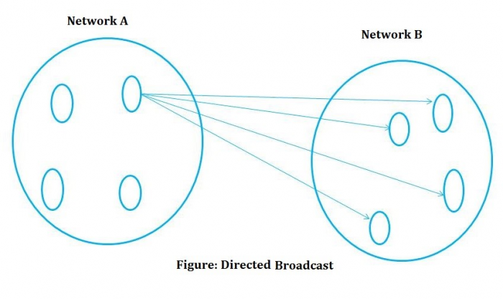

Limited Broadcast
In Limited Broadcast, the data is transmitted from a single source host to all the other hosts residing in the same network.
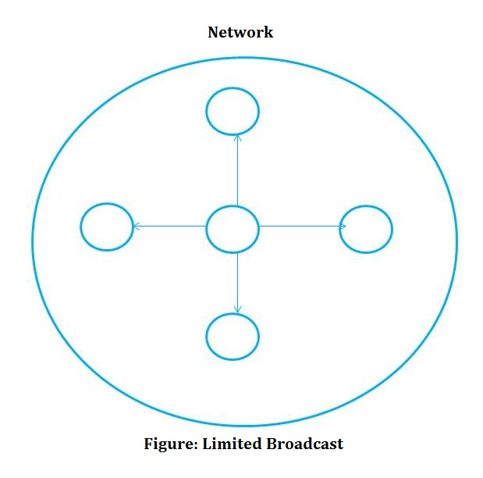

Broadcast routing
By default, the broadcast packets are not routed and forwarded by the routers on any network. Routers create broadcast domains. But it can be configured to forward broadcasts in some special cases. A broadcast message is destined to all network devices.
Broadcast routing can be done in two ways (algorithm):
- A router creates a data packet and then sends it to each host one by one. In this case, the router creates multiple copies of single data packet with different destination addresses. All packets are sent as unicast but because they are sent to all, it simulates as if router is broadcasting.
This method consumes lots of bandwidth and router must destination address of each node.
- Secondly, when router receives a packet that is to be broadcasted, it simply floods those packets out of all interfaces. All routers are configured in the same way.

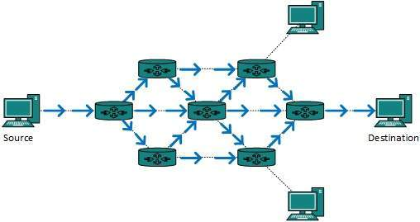

This method is easy on router's CPU but may cause the problem of duplicate packets received from peer routers.
Reverse path forwarding is a technique, in which router knows in advance about its predecessor from where it should receive broadcast. This technique is used to detect and discard duplicates.

Multicast Transmission (One-to-Many)
When the data is transmitted from a single source host to a specific group of hosts having the interest to receive the data, it is known as multicast transmission. Multicast can be more efficient than unicast when different groups of receivers need to see the same data.
Example − Multicast is the technique used in Internet streaming of video or audio teleconference, sending an email to a particular group of people, etc.
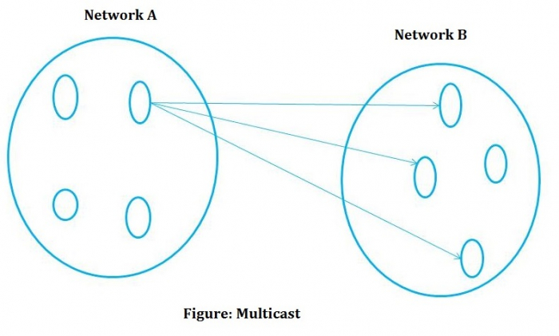
When a device has multiple paths to reach a destination, it always selects one path by preferring it over others. This selection process is termed as Routing. Routing is done by special network devices called routers or it can be done by means of software processes. The software based routers have limited functionality and limited scope.

Multicast Routing
Multicast routing is special case of broadcast routing with significance difference and challenges. In broadcast routing, packets are sent to all nodes even if they do not want it. But in Multicast routing, the data is sent to only nodes which wants to receive the packets.
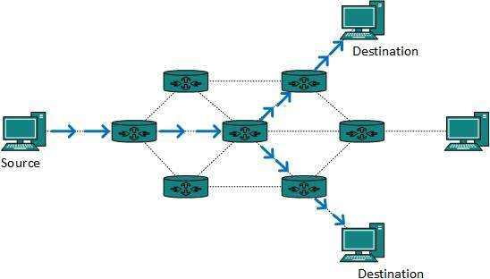
The router must know that there are nodes, which wish to receive multicast packets (or stream) then only it should forward. Multicast routing works spanning tree protocol to avoid looping.
Multicast routing also uses reverse path Forwarding technique, to detect and discard duplicates and loops

Congestion Control in Computer Networks
What is congestion?
A state occurring in network layer when the message traffic is so heavy that it slows down network response time.

Effects of Congestion
- As delay increases, performance decreases.
- If delay increases, retransmission occurs, making situation worse.

Congestion control algorithms
- Congestion Control is a mechanism that controls the entry of data packets into the network, enabling a better use of a shared network infrastructure and avoiding congestive collapse.
- Congestive-Avoidance Algorithms (CAA) are implemented at the TCP layer as the mechanism to avoid congestive collapse in a network.
- There are two congestion control algorithm which are as follows:

- Leaky Bucket Algorithm
- The leaky bucket algorithm discovers its use in the context of network traffic shaping or rate-limiting.
- A leaky bucket execution and a token bucket execution are predominantly used for traffic shaping algorithms.
- This algorithm is used to control the rate at which traffic is sent to the network and shape the burst traffic to a steady traffic stream.
- The disadvantages compared with the leaky-bucket algorithm are the inefficient use of available network resources.
- The large area of network resources such as bandwidth is not being used effectively.
Let us consider an example to understand

Imagine a bucket with a small hole in the bottom.No matter at what rate water enters the bucket, the outflow is at constant rate.When the bucket is full with water additional water entering spills over the sides and is lost.
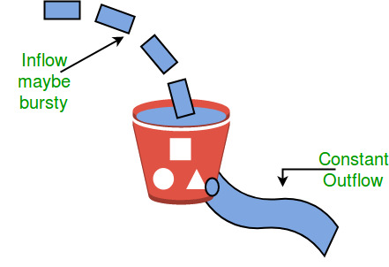

Similarly, each network interface contains a leaky bucket and the following steps are involved in leaky bucket algorithm:
- When host wants to send packet, packet is thrown into the bucket.
- The bucket leaks at a constant rate, meaning the network interface transmits packets at a constant rate.
- Bursty traffic is converted to a uniform traffic by the leaky bucket.
- In practice the bucket is a finite queue that outputs at a finite rate.
- Token bucket Algorithm
- The leaky bucket algorithm has a rigid output design at an average rate independent of the bursty traffic.
- In some applications, when large bursts arrive, the output is allowed to speed up. This calls for a more flexible algorithm, preferably one that never loses information. Therefore, a token bucket algorithm finds its uses in network traffic shaping or rate-limiting.
- It is a control algorithm that indicates when traffic should be sent. This order comes based on the display of tokens in the bucket.
- The bucket contains tokens. Each of the tokens defines a packet of predetermined size. Tokens in the bucket are deleted for the ability to share a packet.
- When tokens are shown, a flow to transmit traffic appears in the display of tokens.
- No token means no flow sends its packets. Hence, a flow transfers traffic up to its peak burst rate in good tokens in the bucket.

